Hearthstone Visualization Design Paper

After finishing the tutorial Hearthstone players are encouraged to begin making decks and competing with other players online. This can be a difficult first move for a player who does not understand the larger context of cards. Specifically creating your first deck from scratch can seem overwhelming without any context for what cards are good compared to all other cards in the game. This problem can be solved by looking at the advantages and disadvantages of each class in the game. Once you have decided what class you want to play, making a deck is much easier since there will by synergies present in the class. There are many resources that exists when trying to make a deck in Hearthstone, for example <http://www.hearthstonetopdecks.com/> is a website that shows which decks are most popular in the games current meta, or competitive scene. A visualization is an appropriate way to address this question because of how large the data set is. When trying to represent so many different cards at once statistical modeling fails to display the comparison between any two cards. With a data visualization however, it is easier to see how any one card compares to the whole set of cards in the game.

The data is structured where each row represents a card, and the columns are different variables of the card. The intended audience is for players that are familiar with the rules of Hearthstone, but want to get better at the game. The audience will need to be able to see more than one classes data at a time so that they can compare the advantages/disadvantages of picking one class over another.

One of the defining characteristics of Hearthstone is the legendary cards, these are very powerful rare cards that make or break most games. Therefore, the more legendary cards a class has the stronger that class is. This is why I decided to see which class has the most legendries? A stacked bar graph like the one below allows the user to see how many legendary cards make up the total count for a specific class, and shows that information for every class.

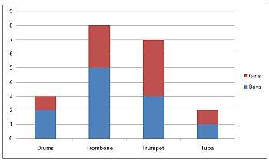

The advantage with this is that it allows for a quick visual comparison that will clearly answer the question. However, having 9 of these bars (for each of the 9 classes in the game) all on the same graph could be overload and messy looking. 00

One big advantages of some decks are their ability to have synergy with a specific race of cards. Some minions are categorized by race, i.e a collection of cards for the hunter class will all be “beasts” or “dragons”. These decks are very strong which begs the question, which class has the most (race) cards? A bar graph like the one below is a unique and interesting way to show how many cards out of the total amount of cards for a class are a specific race.

Image result for bar graph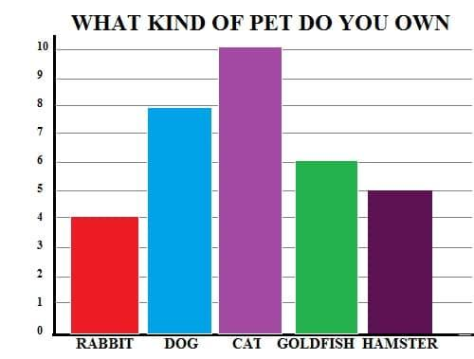

The advantages of this kind of graph is that it shows the data for all classes at the same time which is useful for comparison, however the graph is rather simplistic. The graph will include an interactive component where the user can select which race they want to see. A pie graph could have been used to show this data, but it can only show one classes data at a time so it would require the user to select a different class for every race and this would become annoying when trying to compare the data to other classes.

While minions play a vital role in most decks spells are also crucial to winning matches, some decks are even build using all spells. When trying to build a deck it is important to know wither or not the class you want to pick has a variety of a spells. This is why the next question being investigated is, what class has the largest percentage of spell cards? Using a pie chart like the one below gives a clear indication of what percentage out of all the cards would be spells.

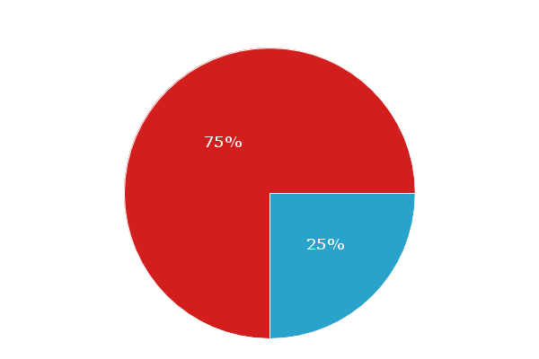

This makes it very easily visually to see if a class is mostly minions or spells. The graph would include an interactive element where users can choose what class to look at using a select box. The disadvantages for this graph however is that users can not directly compare two different classes but instead would have to go back and forth using the select box. However since the amount of total cards a class has would skew the comparison looking at one class at a time is a more accurate answer to this question.

Mana is the main resource of Hearthstone, with more powerful minions and spells costing more mana. Although legendary cards are some of the best cards in the game thy don’t all cost a lot of mana, some have not as powerful effects and therefore cost less. This is what inspired the third question, what class has the lowest mana costs per rarity? Since having lots of legendary cards that cost a little bit of mana is a strong advantage when building a deck. A scatterplot like the one below would be the best for answering this question.

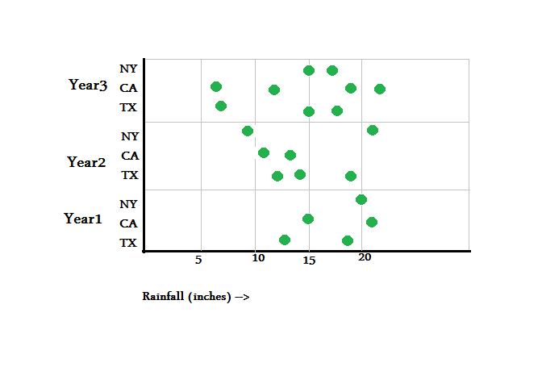

The x variable is the mana cost (0 – 10) and the y variable would be the rarity of the card (common, rare, epic, legendry). The graph would also include an interactive element where the user chooses what classes cards they want to look at by using a selection box. The advantages of this graph is that it can be used to show correlations between mana costs and rarity. However, this doesn’t allow for direct comparison between the different classes. This information however wouldn’t be helpful for all the classes at the same time, the correlation only matters for the one class.

If someone decides that they want to make a deck based off of minions, there are a lot of different options for how they go about it. They could have lots of low mana low health minions to overwhelm the enemy, or lots of high mana high health minions that can do big damage. This inspired the last question, which class has the most minions with (#) health? Using a dot plot like the one below we can compare all the classes to see which one has the most minions of a specific health. Thus graph would include an interactive element where the user uses a slider to determine the health number they want to observe (ex. 2 to 4). The advantage of this graph is that it allows for comparison across all the classes. However, if the user decides to look at too large of a scale (minions from health 0 to 9) the graph will become very messy and hard to read. A bar chart could have been used to present this data, but is simplistic and already been done earlier in the project.

While initially planning this project, I wanted the audience to be people who have never played Hearthstone before. However, this became difficult to make a data visualization with since there are so many concepts that have to be explained. This explanation would require large blocks of text, making the data implementation difficult as well as confusing. To troubleshoot this problem I changed the audience to people who know the rules of Hearthstone but want to get better at the game. During the peer review I was worried that the Hearthstone concepts would be too difficult for someone with no background to understand. I was pleasantly surprised however to see even people who didn’t play games understand the basic rules with little difficulty. This helped inspire me to switch my audience with the presumption that most people will understand the concepts.

The goal of my project is to help Hearthstone players make better decks, specifically to narrow down what class they want to build the deck for. This goal will be achieved by looking at which class has the most legendaries, largest percentage of spell cards, most race cards, lowest mana cost compared to rarity, and minions with # health. The audience will learn what classes are best for specific kinds of decks you want to build. I have learned that the meta game for Hearthstone is very meticulously detailed. Specifically the mana cost per rarity of card is a stat tracked by pro players and is implemented in their deck building. The limitations for this project is that some of the graphs appear cluttered or too full of data. Going forward I would like to use tools like color and shape to make the data easier to read. I am the only person in my group so I have done everything so far.